**COLONIAL NEWS**

Health Committee Newsletter OCTOBER 2023

Welcome to the Albert Gallatin School District Health Committee’s monthly newsletter. Each month this publication will provide our district with health and fitness information. Our goal is for our students, families, and staff to use this information to make healthy decisions and to live a healthy active lifestyle.

Autumn Season Health and Wellness Tips

The weather is changing. There is less daylight and health issues such as colds, stomach viruses, allergies and the flu may start to arise.

Here are some tips to help you stay healthy through the autumn season:

* Get Enough Vitamin D – The days are getting shorter and natural light can lead to a lack of Vitamin D. Health tip -- Try to get outside in the sunlight for at least 15 minutes a day.
* Stay Hydrated – Feeling chilly can dehydrate you just like sweating on a hot day. Health tip – make sure you are getting enough water intake by tracking how much you drink.
* Calories – When we are less active, as we sometimes are when the outside temperatures drop, we need less calorie intake. Health tip -- Those comfort foods can often pack on more calories so evaluate what you eating to keep a healthy weight.
* Handwashing – this routine is not just for the autumn season, but one that should be practiced all year round. Health tip – scrub your hands with soap and water for at least 20 seconds, rinse under clean, running water, dry using a clean towel or air dryer.

Health concerns in the autumn season do not need to become stressful. By following a combination of wholesome habits and staying on top of your wellness visits with your doctor, you can stay healthy and enjoy the autumn season.

(Adapted from Source: Mercyhealth)

For more information visit [https://blog.mercy.com](http://www.nimh.nih.gov)

**Pumpkin pass race**

Tis the season for pumpkins! Encourage your family and friends to stay active this fall season by trying this activity.

* Make teams of participants and ask them line up, place their hands on the person’s shoulders in front of them and then straighten out their arms to make sure there’s some space between each person.
* Give a small pumpkin to the first person in line and have them pass it over their head to the person behind them.
* Pass the pumpkin this way all the way to the back of the line and then back to the front.
* The first team to finish is the winner!

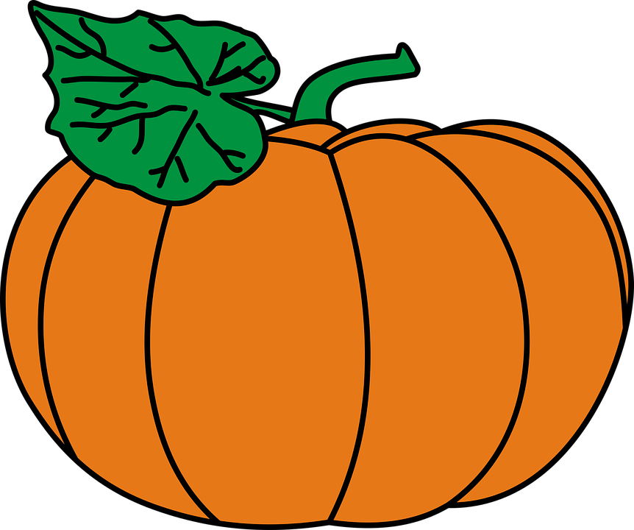

Prepared by Lisa Sumey, Central Office Secretary

   
  
  
  
   
  
 

**Recipe of the Month**

Cinnamon Popcorn

**Ingredients**

* 12 cups popcorn (air popped, with no salt or fat)
* 2 tablespoons light brown sugar
* 1 teaspoon ground cinnamon
* ¼ teaspoon salt
* 2 tablespoons butter, melted

**Instructions**

Combine brown sugar, cinnamon, and salt in a small bowl.

Place popcorn in a large bowl and drizzle with butter; toss to coat.

Sprinkle popcorn with sugar mix and toss well



**energy management**

Your body has a limited amount of energy. The amount varies from person to person due to factors such as age, sleep, stress levels, and medical conditions. Here are some tips to develop an energy management plan.

* Eat Nourishing Food – follow a balanced diet high in fruits and vegetables, lean protein, low-fat dairy and whole grains.
* Sleep – get enough sleep. Adults need at least 7 hours per night, children age 6 – 12 need 9-12 hours sleep per night, and teens age 13 – 18 need 8-10 hours sleep per night.
* Get Regular Exercise – it is recommended adults get 150 minutes per week of moderate-intensity physical activity each week. Children 3-5 years old should be physically active and have plenty of opportunities to move throughout the day. Children 6-17 years old should get at least 60 minutes per day of moderate-to vigorous intensity physical activity.
* Think Good Thoughts of Others – Maintain a compassionate mindset. Practice kind attention by making eye contact with others, smile, wish them well.
* Plan and Prioritize --- Take notice of the times during the day when your energy levels tend to be the highest and decide how you can take advantage of those moments by prioritizing important tasks.

(adapted from Source: Mayo Clinic Health System)